This tutorial will explain how to teleport an object, like a bridge, when another object is collided with in 2D.

1. In Unity, set up a scene like this. The green square will be the button and the brown square the bridge. Just above the button, add another square sprite where you would like the bridge to teleport too. I made mine transparent. 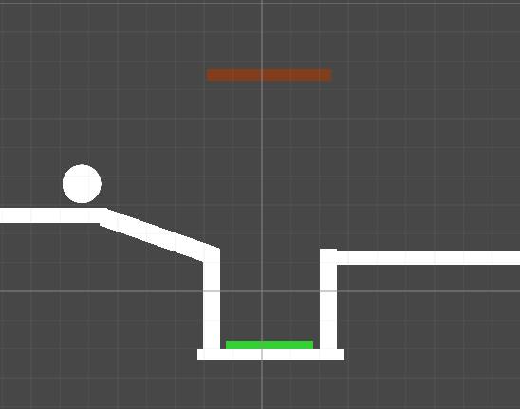
2. You’ll need to attach 2D box colliders to all of the sprites (under the inspector tab when you select the object) **except** for the transparent sprite, then add a 2D rigidbody to the circle too. This will add physics to the sprites so that the collision can be detected properly.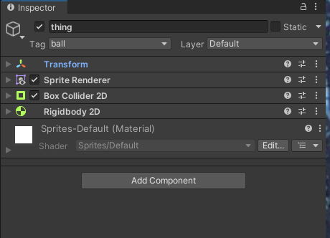
3. On the ball sprite, add a new tag and name it ball, then on the bridge add a new tag called bridge. These will be used later in the script.
4. Create a new C# script and name it something relevant, like Button, then open it.
5. Start by making these three variables below.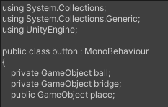
6. Under void Start, we will use these two lines of code. This is finding the Game objects in our project with the tags ‘ball’ and ‘bridge’, and assigning them to the variables we created above. 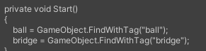
7. Create a new private void with OnTriggerEnter2D as written below. This allows us to use collision physics in our code. The if statement below will run if the button is collided with an object that has the ‘ball’ tag. If it runs, the object assigned to the ‘bridge’ variable will be teleported into the same position that the object assigned to the ‘place’ variable is in.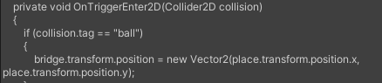
8. Save the code then go back into Unity. Select the button, then attach the script. Under the Place variable, drag the transparent sprite from earlier into that section as below.
9. Save your project and test. (You may need to move the ball onto the slope).